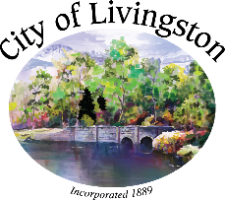

A Special meeting of the City Tree Board Meeting Committee has been scheduled for April 13, 2023 at 12:00 PM by Zoom Only. This meeting will be facilitated by Laurel Desnick.

Join this meeting:

<https://us02web.zoom.us/j/87876009443?pwd=aDVjVEpLYTAzMlg1Mkl6cWNBS2VSdz09>

Meeting ID: 878 7600 9443

Passcode: 864493

One tap mobile

+16699006833,89650751355#,,,,*975297# US (San Jose)

1. Roll Call

2. Approval of Minutes

3. New Business

4. Old Business

**A. 2023 Arbor Day Celebration in Livingston Planning Discussion.**

5. Public Comments

6. Board Comments

7. Adjournment